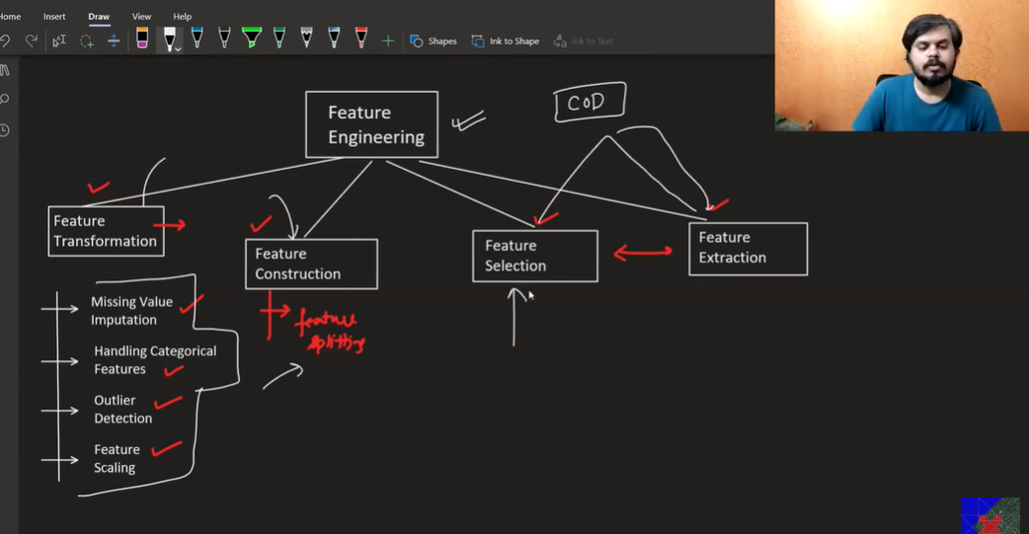

Feature Engineering padhunga baadmai !

Feature Transformation & Feature Construction,

**Feature Selection & Feature Extraction dono related hai Curse of Dimensionality se**

Feature Extraction ka imp technique hai PCA

***Curse of Dimensionality 🡪***

***Curse of Dimensionality***

Machine Learning mai Columns hote as data mai , unhe hum Features bolte hai

**Curse of Dimensionality ko hum Curse of Features bhi kehsakte hai**

Ek Level kebaad aur zyaada Features add nahi krna chaye, their must be Optimal Number of Features.

Zyaada unimpactive Features add karke kuch meaning nahi hai balki ushse Problem hie hoskta hai

Performance girayega balki vo

Jaise jaise Features add krte jaarhe hoo vaise vaise Performance badega Model ka but at certain point

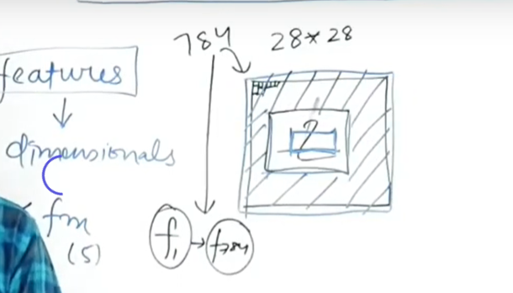

ML mai bht baar esa hoga ki High Dimension Data set millega

E.g 1.) at time of working with Images

2.) At time of working with Text

Yeahdono time tumhe high dimension features milenge

Higher Dimension Space mai problem kya hai ??

**Reason 1 word mai Sparsity hai**

**Violet khoneka E.g Suppose tumhare Violet khogaya**

**Tou yeah batao ki Violet ko dhundna kaha easy hoga ?**

1. **Road**
2. **Huge Complex Building**
3. **Playground**

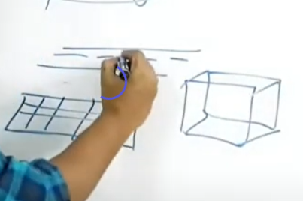

Road mai sbhse easy hoga coz vo 1d hai

& baki mai hard hai coz jaise high dimension mai jayenge vaise vo 1 data point eg violet dhundna hard horha hai

**Higher Dimension mai Data Sparse horaha hai**

**Har data point ek dusre se durr horaha hai**

**Higher Dimension mai Sparsity create horaha so problem horahi So ML Algo ka performance khrbh horha & computation bhi heavy horha**

**To Solve this issue**

**We use**

**Dimensionality Reduction**

**We Reduce Number of Columns ese dimensions hatadete hai**

**Iske 2 Tarike hote hai ismese koi 1 Tarika use karke Hum Dimensionality Reduce krte hai (columns reduce krte hai )**

1. **Feature Selection (isme Feature Select krte hai hum )**
2. **Feature Extraction**

**Feature Extraction mai 3 technique use hote hai**

1. **PCA ( Principal Component Analysis**
2. **LDA**
3. **TSNE**